 |  |  |  | QUANTITY | PER
BOLT CYLINDER HEAD | 32181424/ 32166339/ 104MM | MF 290 | 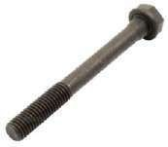 | 400 | EACH
BOLT CYLINDER HEAD | 32181425/ 32166338/ 120MM | MF 290 |  | 400 | EACH
BOLT CYLINDER HEAD | 32181426/ 32166337/ 125MM | MF 290 |  | 400 | EACH
TAPPET | 3143U031/ 31434161/  31434162/ 31434163/  31434165/ 740671M1/  42220691M1 | MF 290 | 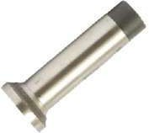 | 1000 | EACH
ROCKER ASSY. | Zz90007/ Zz90030/ Zz90158/ 87114/ 3637391M91/ Zz90158/ Zz90171/ ZZ90199 | MF 290 | 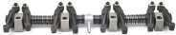 | 20 | EACH
SPACER CRANKSHAFT | 31186137/ 32186139/  3242T001/ 3271R021/  3638113M1/ 36378115M1 | MF 290 | 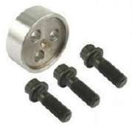 | 40 | SET
CAMESHAFT | 31415361/ 31415363/  3641840M91/ 2487863/  897105M1 | MF 290 | 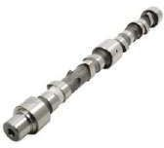 | 50 | EACH
BUSH CAMESHAFT | 31134132/ 31134163/  31134164/ 31134165/  3638093M1/ 3638579M1/  4222017M1/ 734883M1 | MF 290 | 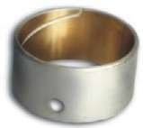 | 400 | EACH
HOLDER | 9430032200/ 2646460 | MF 290 | 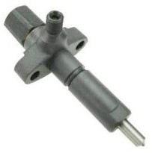 | 20 | EACH
THERMOSTAT VALVE 74’ | 2485635/ 2485645/ 2485648/  2485653/ 2485666/ 32550/  828139M1/ Pf52842/  1446165M91 | MF 290 | 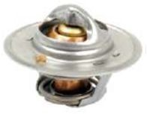 | 50 | EACH
EXHAUST ELBOW | 1862807M1 | MF 290 | 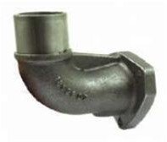 | 50 | EACH

RELEASE SPRING | 1753745M1/ 1753746M1/  886396M1/ 886632M1/  887909M1/ 899816M1 | MF 290 | 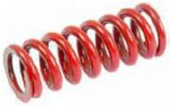 | 100 | SET
SEAL HOUSING MAIN DRIVE | 1860867M1/ 1860867M3/  1860867M4/ 1869867M5 | MF 290 | 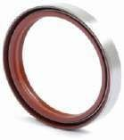 | 300 | EACH
SEAL HOUSING MAIN DRIVE | 186011M3 | MF 290 | 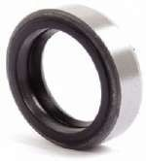 | 300 | EACH
PINION INTERMEDIATE SPEED | 180419M1 | MF 290 | 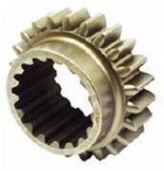 | 25 | EACH
NUT PINION | 180456M1/ 3596252M1/  532956M1 | MF 290 | 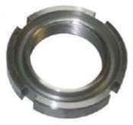 | 50 | EACH
SEAL PTO SHAFT | 3699801M1 | MF 290 | 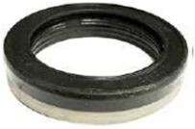 | 200 | EACH
LOCATING PIN/ PIN PUMP SUPPORT | 898643M1 | MF 290 | 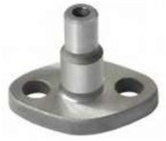 | 100 | EACH
SPRING BRAKE PEDAL | 190978M1 | MF 290 | 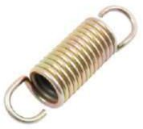 | 300 | EACH
SPRING | 1805985M1/ 1853148M1/  1886562M1 | MF 290 | 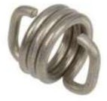 | 300 | EACH
POWER STEERING PUMP | 1662243M91/ 897146M94/  897147M94/ 897147M95 | MF 290 | 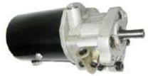 | 20 | EACH
STEERING SEAL | 1850519M1 | MF 290 | 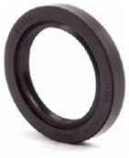 | 300 | EACH

CUP GEAR LEVER SHIFT | LONG HT. | MF 290 | 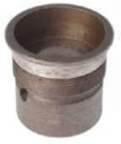 | 50 | WITH NUT
TOP BOTTOM GASKET KIT | U5LT0015/ U5LT0016/  U5LT0007/ U5LT0008 U5LT0035/ U5LT0036/ U5LT0042/ U5LT0045 U5LT0053/ U5LT0174/ U5LT0515/ U5LT1014  68248/ 81563/ 82866/ 82890/ | MF 290 | 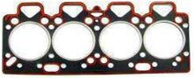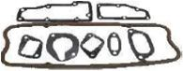 | 100 | SET
HEAD GASKET | 36812315/ 36812323/  36912326/ 36812331  36812333/ 36812334/  36812336/ 36812338  36812342/ 36812349/  36812351/ 3681E021  3681E018/ 3681E007/ | MF 290 | 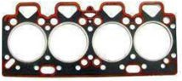 | 100 | EACH
ENGINE OVERHAUL KIT | 98.47 MM PISTON | MF 290 | 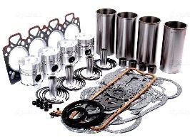 | 300 | SET
INLET VALVE / EXHAUST |  | MF 290 | 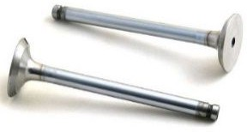 | 150 | SET
VALVE GUIDE | 3343F041/ 3343F031/  4223073M1/ 3637056M1/  3640676M1/ 736291M1/  736297M1/ 747723M1/  33261731/ 33261732/  3343F002 | MF 290 | 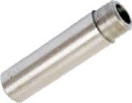 | 150 | SET
SEAL BRAKE DRUM | 1860482M91/ 832954M1/  832954M3/ 881021M93 | MF 290 | 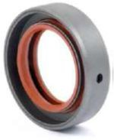 | 200 | EACH
VALVE STEM SEAL | 33817125/ 3637041M1/  33817117 | MF 290 | 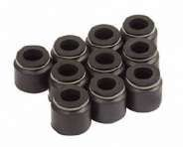 |  | EACH
FRONT HOUSING SEAL | 2415361/ 2418F436/  1447690M1/ 02101435/  218375A1/ 7701031630/ SIZE  60.33 x 79.4 x 9.5/ 11.2 MM | MF 290 | 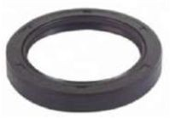 | 100 | EACH
REAR COVER SEAL | 2415390/ 2415391/  1447049M1/ 218271A1/  2418F475/ 1447691M1/  1447691Z1/ 7701030494/ SIZE 133.35 x 158.75 x 12.7 MM | MF 290 | 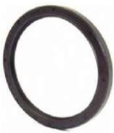 | 100 | EACH
SEAL REAR AXLE | 2162850/ 3699800M1/  3699800M2/ 894736M4/  894763M2/ 894763M3/  894763M4/ 894763M5 | MF 290 | 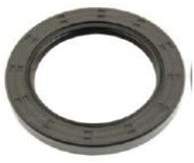 | 200 | EACH

SEAL FRONT WHEEL HUB | 897702M1 | MF 290 | 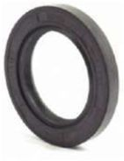 | 200 | EACH
CONNECTING ROD BOLT AND NUT | 32762145/ 32762116/  32762144/ 33221328/  3637029M1/ 3637030M1/  376568X1/ 1476232X1/  4222485M1/ 33221328 | MF 290 | 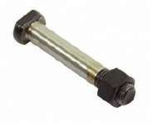 | 2000 | EACH
BUSH CONNECTING ROD | 31134123/ 733767M1 | MF 290 | 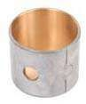 |  | EACH
MAIN BEARING | 81558/ 31126361/ 31126391/  41157201/ 735168M91/  3118150R1/ U5MB0034/  40339/ 423669 | MF 290 | 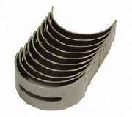 | 250 | SET
CONNECTING ROD BEARING | 85042/ 31126311/  736850M91/ 736950M91/ U5ME0002 | MF 290 | 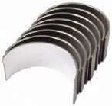 | 250 | SET
THRUST WASHER | U5TW0002/ TOP-31137311/ 31137551/ 747128M1/ BOTTOM-31137561/ 31137321/ 747129M1 | MF 290 | 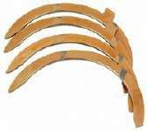 | 100 | SET
BUSH CENTRE AXLE | 897235M2/ 194624M1/  843854M1 | MF 290 | 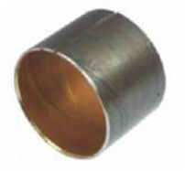 | 500 | EACH
BUSH SPINDLE SHAFT | 183086M1 | MF 290 | 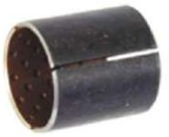 | 0 | 4 PCS SET
WASHER PALENTRY THRUST | 1866545M2 | MF 290 | 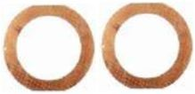 | 50 | SET
CRANKSHAFT | Zz90202/ 3637402M91/ 3640408M91/ 4223939M91/  4224669M91/ SPLINED NOSE/ LIP SEAL/ 3 HOLES FOR PULLEY FITTING | MF 290 | 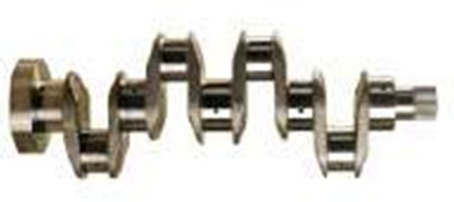 | 50 | EACH
RING GEAR | 355228M1/ 126 TEETH | MF 290 | 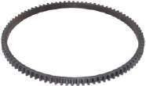 | 100 | EACH

METERING VALVE | 7139-559 T | MF 290 | 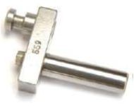 | 150 | EACH
METERING VALVE | 7123-930 | MF 290 | 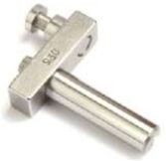 | 150 | EACH
METERING VALVE | 490E | MF 290 | 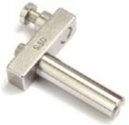 | 150 | EACH
NOZZLE | 150S-6705/ 2646677/  2646695/ 2646842/  1447227M1 | MF 290 | 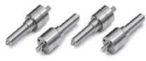 | 5000 | EACH
DRIVE HUB | 7123-549 | MF 290 | 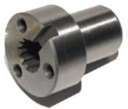 | 50 | EACH
DRIVE SHAFT | 7139-657C | MF 290 | 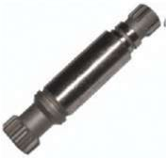 | 50 | EACH
BRAKE ADJUSTING PIN | 1863642M1/ 182723M1/  1888905M1/ 188909M1/  881727M1/ 881729M1/  182723M1/  188909M1/3534030X1/  375108X1/ 881727M1/  881728M1/ 881729M1 | MF 290 | 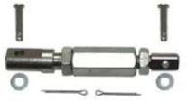 | 600 | EACH
BUSH CAME BLOCK | 180914M1/ 180924M1/  894607M1 FRONT/  180325M1/ 180925M2/  894608M1 REAR | MF 290 | 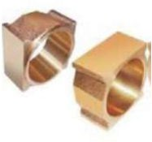 | 25 | SET
BUSH IDLER GEAR | 0050345/ 2511A735/  3637942M1 | MF 290 | 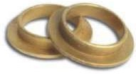 | 25 | SET
OIL FILTER HEAD | 37764181/ 741614M1 | MF 290 | 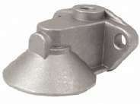 | 100 | EACH
FUEL FILTER ASSY. | 2656615/ 883786M91/  894976M91/ 5836B325/  5836B320/ 5836B100/  12656615/ 49667/ THREAD  ½”UNF | MF 290 | 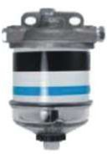 | 100 | EACH

FUEL FILTER ASSY. | 2656615/ 883786M91/  894976M91/ 5836B325/  5836B320/ 5836B100/  12656615/ 49667/ THREAD  ½”UNF | MF 290 | 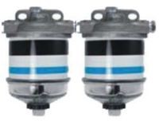 | 50 | EACH
FUEL FILTER | 7111-296 | MF 290 | 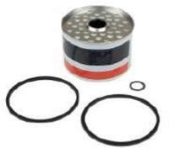 | 1500 | EACH
OIL FILTER | 2654403/ 2654153/ 2654343/  2654347/ 2654404/  1447031M1/ 1447048M1/  3540049M91/ 3652517M91/  881304M91/ 360256/  895293R91/ 918266R91 | MF 290 | 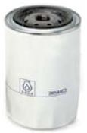 | 500 | EACH
GEAR DRIVE TACHOMETER | 1446059M1/ 1853144M1/  2758346/ 2758347/ 2758348/  3699203M91 | MF 290 | 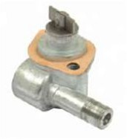 | 25 | EACH
LEAK OFF PIPE | 35587344/ 734723M91 | MF 290 | 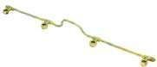 | 50 | EACH
INJECTOR PIPE SET | 35343025/ 35343136/  35354266/ 35354317/  3641094M91/ 735099M91/  744512M91 - NO.1/  35343026/ 35343137/  35354267/ 35354316/  3641262M91/ 735100M91/ | MF 290 | 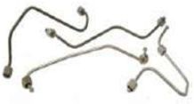 | 100 | SET
FUEL PUMP REPAIR KIT | 7135-110 | MF 290 | 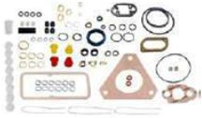 | 500 | SET
HYD.O’RING KIT | 1810680M92/ 1810680M93 | MF 290 | 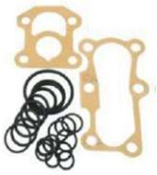 | 500 | SET
END PLATE | 7135-180 | MF 290 | 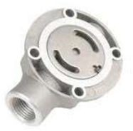 | 50 | EACH
WATER PUMP | 41313231 | MF 290 | 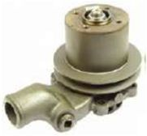 | 100 | EACH
RADIATOR HOSE | 899144M1/898748M1 | MF 290 | 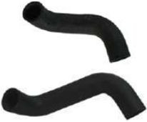 | 100 | SET

FAN BLADE | 15” 6 BLADES | MF 290 | 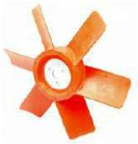 | 100 | EACH
PIPE PRE CLEANER | 1682795M1/ 3821793M91 | MF 290 | 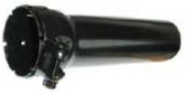 | 50 | EACH
EXHAUST MANIFOLD | 37781781/ 736206M1 | MF 290 | 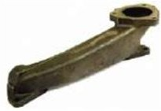 | 50 | EACH
DRIVEN PLATE PTO | 1486544M91/ 1865836M1/  1867386M91/ 3478359M91/  3620417M91 | MF 290 | 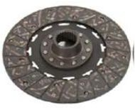  10" / 25 TEETH | 50 | EACH
DRIVEN PLATE CLUTCH | 1486583M91/ 1680871M91/  1866042M93/ 3599462M92/  887889M94/ 907090M93 | MF 290 | 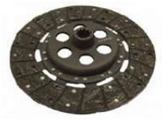  12" / 10 TEETH | 50 | EACH
DRIVEN PLATE CLUTCH | 1693884M91/ 3597096M91/  3597670M91/ 3599459M91/  3599460M92/ 3610274M92/  3610274/ 610274M92 | MF 290 | 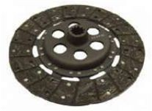  12" / 21 TEETH | 50 | EACH
CARRIER CLUTCH HUB | 886727M1/ 886727M2/  886727M3/ 886727M4 | MF 290 | 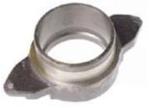 | 50 | EACH
FORK CLUTCH RELEASE | 180452M1/ 886719M1 | MF 290 | 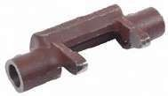 | 50 | EACH
SPRING AND PLUNGER LONG | 180418M1/ 180418M2 PLUNGER/ 180417M1/ 191221M1 SPRING | MF 290 | 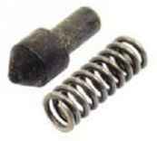 | 100 | 4 PCS SET
FOOT ACCELERATOR | 160412SN/ 0012347A | MF 290 | 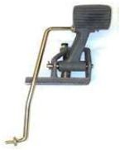 | 150 | EACH
PTO PINION | 1868530M91/ 1868531M1 | MF 290 | 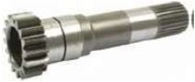 | 25 | EACH

PTO PINION | 1671704M91/ 16717175M1/  1671705M91 | MF 290 | 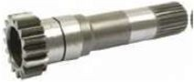 | 25 | EACH
PINION MAIN DRIVE SHAFT | 26/10 TH | MF 290 | 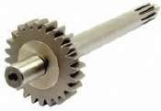 | 25 | EACH
PINION MAIN DRIVE SHAFT | 26/21 TH | MF 290 |  | 25 | EACH
PINION MAIN DRIVE SHAFT | 24/10 TH | MF 290 |  | 25 | EACH
GEAR LOW SPEED | 1660917M3/ 1682688M1/  1682689M1/ 189439M1/  520700M3 | MF 290 | 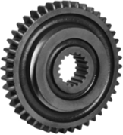 | 25 | EACH
SHAFT MAIN TRANSMISSION | 168244M91/ 1687643M1 | MF 290 | 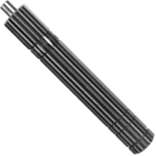 | 25 | EACH
SHAFT MAIN TRANSMISSION | 1682448M1/ 1687642M1/  1867990M1 | MF 290 | 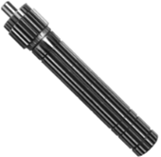 | 25 | EACH
GEAR PALENTRY RING | 1866541M3/ 1867242M2 | MF 290 | 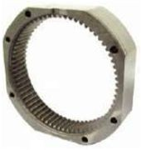 | 25 | EACH
COUPLER PALENTRY SHIFT | 184770M2/ 184770M3 | MF 290 | 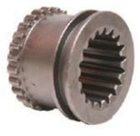 | 25 | EACH
COUPLER PALENTRY SHIFT | 1866557M1/ 1866557M2/  2700374M1 | MF 290 | 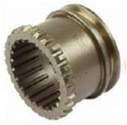 | 25 | EACH
GEAR PTO | 53/21 TH | MF 290 | 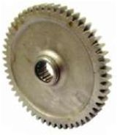 | 25 | EACH

GEAR CONSTANT MESH | 42/20 | MF 290 | 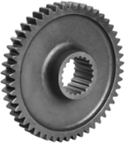 | 25 | EACH
GEAR CONSTANT MESH | 45/20 | MF 290 | 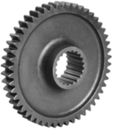 | 25 | EACH
COUNTER SHAFT | 1660916M91/ 195453M1/  906472M2/ 906473M2 | MF 290 | 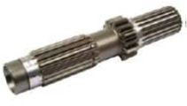 | 25 | EACH
PINION CLUSTER HIGH SPEED | 180415M1 | MF 290 | 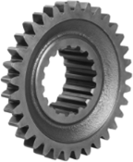 | 25 | EACH
PINION MAINSHAFT 3RD | 964916M1 | MF 290 | 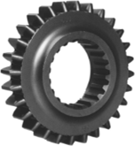 | 25 | EACH
GEAR 3RD MAINSHAFT | 1660094M1/ 1682690M1/  964917M1 | MF 290 | 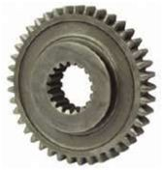 | 25 | EACH
REVERSE GEAR | 1660919M1/ 183040M1/  183040M91 | MF 290 | 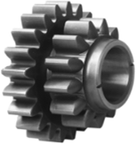 | 50 | EACH
GEAR | 32/18 | MF 290 | 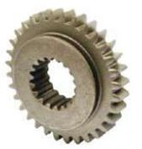 | 25 | EACH
PTO SHAFT | 1660288M91/ 3599003M91/  3774418M91 | MF 290 | 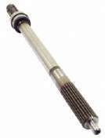 | 10 | EACH
PINION | 184176M1/ 894769M1 | MF 290 | 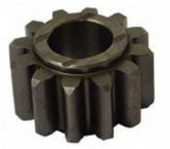 | 50 | EACH
GEAR PALENTRY | 1808251M1/ 897005M1 | MF 290 | 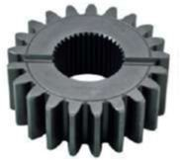 | 30 | EACH

REAR AXLE |  | MF 290 | 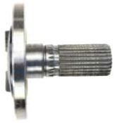 | 10 | EACH
SHAFT REAR DRIVE | 1868539M1 | MF 290 | 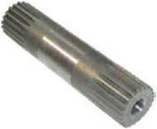 | 0 | EACH
KIT CROWN WHEEL & PINION | 1660688M91/ 1661608M91/  1664255M92/ 1885318M93/  888358M91 | MF 290 | 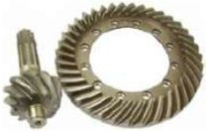  11/38 TEETH | 25 | SET
CARRIER UNIT EPICYCLIC | 1870538M1/ 1870538M92/  1870538M93/ 1888677M91 | MF 290 | 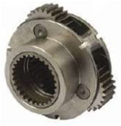 | 25 | EACH
KIT ROLLER REVERSE CLUSTER | 830735M91 | MF 290 | 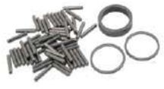 | 100 | SET
SNAP RING KIT | 195499M11 | MF 290 | 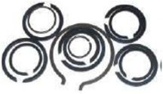 | 50 | SET
BOLT AND NUT REAR AXLE | 847416M1 BOLT/ 847417M1 NUT | MF 290 | 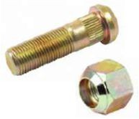 | 800 | EACH
BOLT FRONT WHEEL HUB | BOLT 181328M1/ NUT 195490M1 | MF 290 | 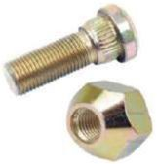 | 600 | EACH
CROWN WHEEL BOLT & NUT | 390777S/ 712502M1/  81716988/ 825776M1/  83957533 BOLT/ 380135S43/  712503M1/ 83417169/  891947M1 NUT | MF 290 | 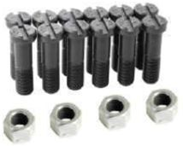 | 480 | EACH
KIT GEAR DIFFERENTIAL | LONG HT. | MF 290 | 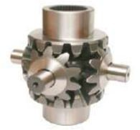 | 25 | SET
SHAFT REDUCTION UNIT | 1664369M1/ 1864869M1 | MF 290 | 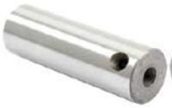 | 200 | EACH

PIN FRONT AXLE | 1684285M1/ 3599732M1/  898016M3 | MF 290 | 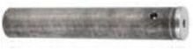 | 50 | EACH
RING REAR AXLE | 882601M1 | MF 290 | 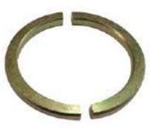 | 0 | SET
SEAL BRAKE BOOT | 1860959M1/ 5117518/  7700014999/ 81902550/  82037652/ 83963609/  85999093/ 86576339 | MF 290 | 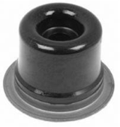 | 200 | EACH
CYLINDER PISTON RINGS | 3761476M1 SEAL/  1693932M91/ 3761473M1 O’RING | MF 290 | 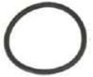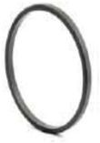 | 100 | SET
BRACKET | 1860972M1/ 847705M2/  1667224M1 | MF 290 | 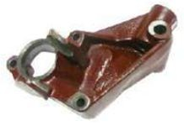 | 50 | EACH
BRACKET | 1860970M1/ 1860969M1 | MF 290 | 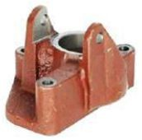 | 50 | EACH
HYD.PUMP ASSY. | 3761330K91 | MF 290 | 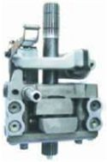 | 10 | EACH
HYD.PUMP ASSY. WITH PRESSURE CONTROL UNIT | 1672251M92/ 1675125M92/  1868439M98/ 1872449M96/  1870995M92 | MF 290 | 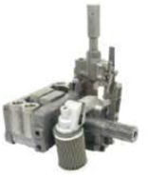 | 10 | EACH
CAMESHAFT | 1871781M92 | MF 290 | 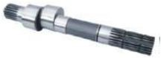 | 10 | EACH
SQUARE PISTON | 1860038M1/ 897492M1/  518476M1/ 56002104 | MF 290 | 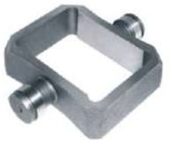 | 50 | EACH
CHAMBER VALVE ASSY. |  | MF 290 | 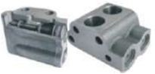 | 50 | VALVE AND KIT FITTED

CHAMBER VALVE KIT | 1810678M91/ 1810678R91/  1868743M1/ 894907M91/  827718M2 | MF 290 | 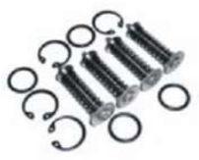 | 25 | SET
ASSY.CONTROL VALVE | 1681789M1 | MF 290 | 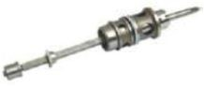 | 200 | EACH
RELEIF VALVE | 828927M1/ 5600210 | MF 290 | 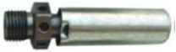 | 200 | EACH
RELEIF VALVE PRESSURE CONTROL VALVE | 1860061M91/ 1869966M96 | MF 290 | 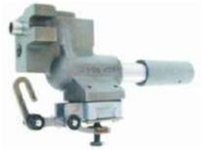 | 25 | EACH
HYD REPAIR KIT MINOR | 1810860M91 | MF 290 | 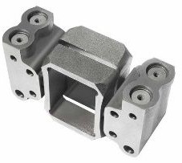 | 50 | SET
ASSY.LIFT CLEVIS |  | MF 290 | 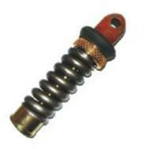 | 50 | EACH
CYLINDER RAM WITH PISTON AND RINGS |  | MF 290 | 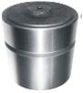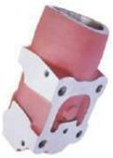 | 10 | SET
RINGS SQUARE PISTON | 897493M1 | MF 290 | 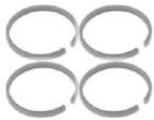 | 200 | SET
STRAINER | 1660715M92/ 1687042M91/  1870199M92/ 1810744M91 | MF 290 | 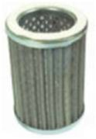 | 200 | EACH
LIFT SHAFT | 897567M1/ 899149M3 | MF 290 | 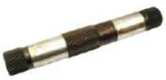 | 50 | EACH
FRONT WHEEL HUB | 898346M93/ 898347M92 | MF 290 | 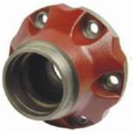 | 100 | WITH HUB CAP

CAP FRONT WHEEL HUB | 882637M1 | MF 290 | 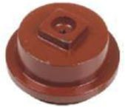 | 100 | EACH
STEERING WHEEL | 1671945M1/ 3303415M91/  894737M1/ 960840M1 | MF 290 | 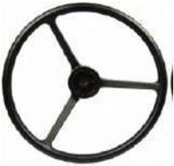 | 50 | EACH
TIE ROD END SET |  | MF 285 | 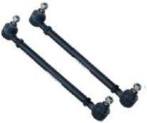 | 100 | 5 PCS SET
ARM LIFT | 1680040M91 | MF 290 | 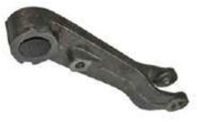 | 50 | EACH
STEERING ARM | 1875775M1/ 898354M1 | MF 290 | 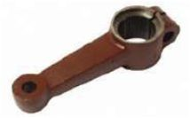 | 50 | EACH
STEERING ARM | 898355M1 | MF 290 | 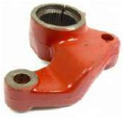 | 50 | EACH
STEERING ARM | 1671335M1/ 1875776M1/  898358M1 | MF 290 | 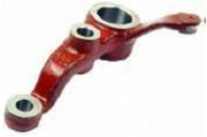 | 50 | EACH
SHAFT PITMAN | 1676666M1/ 898023M2 | MF 290 | 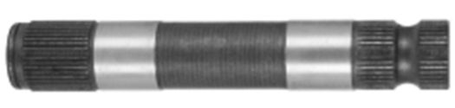 | 50 | EACH
SHAFT PITMAN | 1676665M1/ 898359M2 | MF 290 | 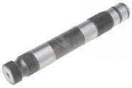 | 50 | EACH
CRANK ARM | 1676664M1/ 897923M1/  897923M2 | MF 290 | 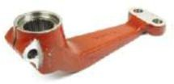 | 50 | EACH
STEERING ASSY. | 1687020M91/ 1687020M92/ INCLUDES. SHAFT NUT TYPE 165411M91/ 1675411M91/  3473254M91 | MF 290 | 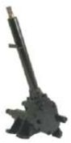 | 25 | EACH

STEERING SHAFT | 165411M91/ 1675411M91/  3473254M91 | MF 290 | 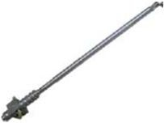 | 50 | EACH
SECTOR SHAFT | 1806227M91 | MF 290 | 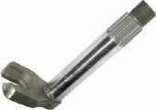 | 50 | EACH
KPH CABLE | 1682557M91/ 1853233M1/  1875889M91/ 1876289M92/  882021M91/ 882026M91/  1355 MM, THREAD 5/8 & ½ | MF 290 | 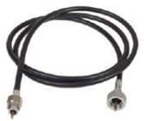 | 50 | EACH
STARTER MOTOR | 1447731M1/ 1680064M1/  1691806M1/ 1860093M2/  1868285M2/ 1868285M3/  1868285M91/ 1868287T/  2873003/ 2873B072/  3597372M1/ 3597372M2 /  3597372R2/ 3763362M91/ | MF 285 | 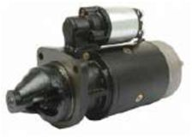 | 80 | EACH
ALTERNATOR | 1672844M1/ 1676689M92/  1699871M1/ 1879264M91/  1895271M91/ 1897264M91/  1897271M91/ 508545M92/  34 AMP | MF 285 | 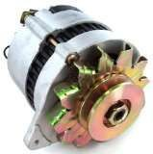 | 50 | EACH
IGNITION SWITCH | 1446116M91/ 1808525M1/  1865976M91/ 1874120M93/  1874535M3/ 2846121/  2846122/ 2846127/ 2846128/  2846129/ 2846130/ 34228 | MF 290 | 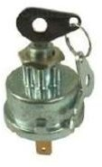 | 100 | EACH
LIGHT SWITCH | 1425878M91/ 1619886M1/  1668816M2/ 1699034M1/  963757M2/ 964248M1 | MF 290 | 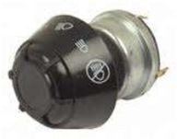 | 100 | EACH
AMPERE GUAGE VOLTMETER | 2757182/ 36047/ 36047F/  36351/ 827055M1 | MF 290 | 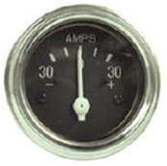 | 80 | EACH
TEMPERATURE GUAGE MANUAL | 1850512M94/ 1078125M91/  180727M91/ 180727M92/  180727M93/ 881369M91/  881396M1/ 881396M91/  899455M91/ DIA 52MM | MF 290 | 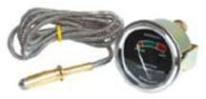 | 80 | EACH
FUEL GUAGE | 1877717M93/ 3381908M1  908427M1/ 962399M1/ DIA  52MM | MF 290 | 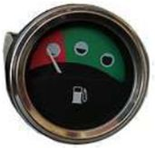 | 80 | EACH
OIL GUAGE | 1458875M91/ 1850337M96/  1850377M96/ 1853097M91/  3381907M1/ 506902M92/  908428M1/ 960265M1/ DIA  52MM | MF 290 | 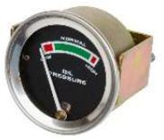 | 80 | EACH

KPH TRACTORMETER CLOCK WISE | 899419M92/ 899421M91/ DIA 85MM | MF 290 | 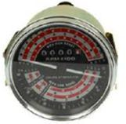  CLOCK WISE | 80 | EACH
STEERING BEARING | 1883133M91/ 1883133V91 | MF 290 | 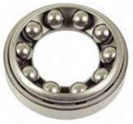 | 500 | EACH
 |  |  |  |  | TOTAL
 |  |  |  |  | CONTAINER 40 FEET
 |  |  |  |  | GRAND TOTAL

